|  |  |
| --- | --- |
| Member | Use Case |
| 姜睿宇 | 活动日历 |
| 蒋子仪 | 模拟抽卡 |
| 陈经纬 | 百科图鉴 |
| 潘义 | 游戏资讯 |
| 苏建锐 | 论坛 |
| 张培洋 | 查询检索 |

一、陈经纬

(1) use case diagram

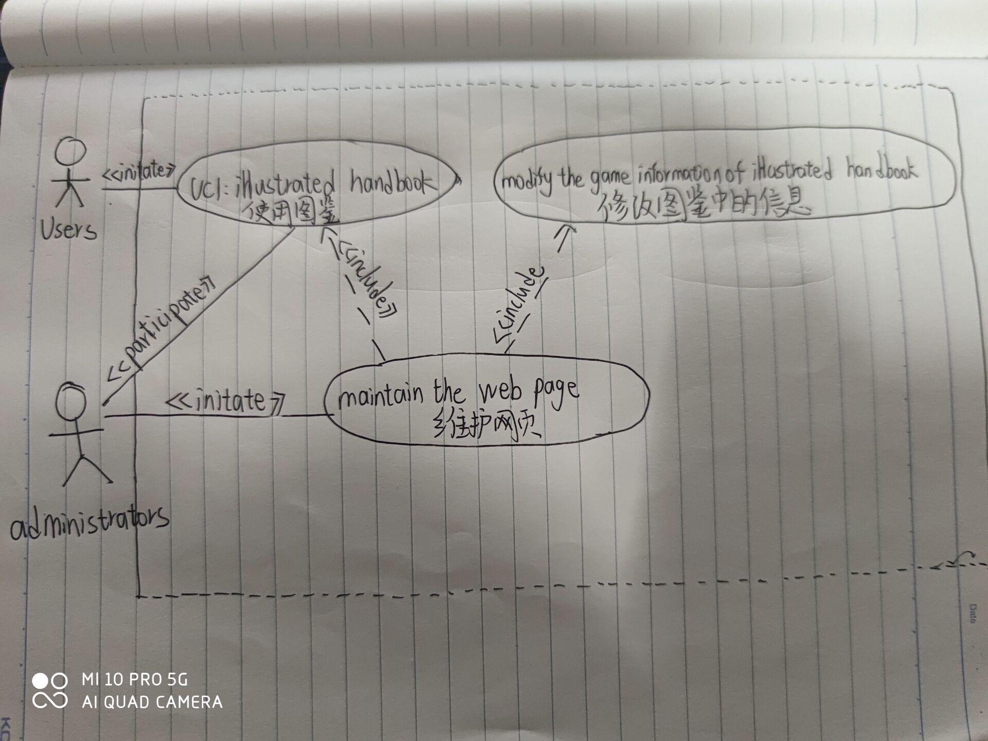

(2) use case schema

|  |  |  |  |
| --- | --- | --- | --- |
| Use Case UC-1: illustrated handbook | | | |
| Related Requirements: | | | REQ1: User can login to the web.  REQ2: Administrators maintain the web. (such as add information……) |
| Initiating Actor: | | | User |
| Actor’s Goal: | | | To display game information with illustrated handbooks  User can use the illustrated handbook to find the game information they need |
| Participating Actors: | | | Web，database, Administrators |
| Preconditions: | | | Administrators add information to the web page of illustrated handbook  User can use the web without occurring some errors |
| Postconditions: | | | Game information are added to illustrated handbook.  User can use the illustrated handbook to find the game information they need |
| Flow of Events for Main Success Scenario: | | | |
| → | 1 | Administrators add information to the web page of illustrated handbook | |
| → | 2 | User login to the web | |
| → | 3 | User go to the web page of illustrated handbook | |
| ← | 4 | The web page of illustrated handbook displays the game information. | |
| → | 5 | User search the illustrated handbook to find the game information they need. | |

1. acceptance test

|  |  |
| --- | --- |
| Test-case Identifier: TC-1  Use Case Tested: UC-1，main success scenario  Pass/fail Criteria: Users can use the illustrated handbook to find the game information they need without occurring some errors.  Input Data: game information in illustrated handbook, User information | |
| Test Procedure: | Expected Result: |
| Step 1. User login and go to the web page of illustrated handbook.  Step 2. User login and go to the web page of illustrated handbook. | The web page of illustrated handbook displays the game information and users search the illustrated handbook to find the game information they need.  The web page of illustrated handbook occurs some errors and can’t displays the game information.  Users can’t search the illustrated handbook to find the game information they need. |

1. system sequence diagram



二、蒋子仪

(1) use case diagram

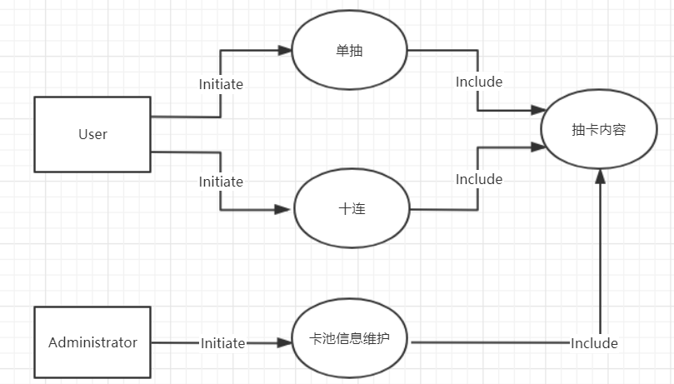

(2) use case schema

|  |  |
| --- | --- |
| Use Case UC-2 | Simulation of Supplication |
| Related Requirements | 模拟抽卡 |
| Initiating Actor | User |
| Actor’s Goal | 模拟抽卡 |
| Participating Actors | Web Database |
| Preconditions | 当期卡池信息已经录入 |
| Postconditions | 模拟抽卡结果显示 |
| Flow of Events for Main Success Scenario | →1.Administrator更新当期卡池信息  →2.User点击“单抽”或者“十连”  ←3.Web显示模拟抽卡结果 |

1. acceptance test

|  |  |
| --- | --- |
| Test-case Identifier | TC-2 |
| Use Case Tested | UC-2 |
| Pass/Fail Criteria | 每90次必由1个5星，  每2次五星必由1个UP5星。  每10次必有1个4星，  每2次4星必有1个UP4星。 |
| Input Data | 当期卡池信息 |
| Test Procedure | Expected Result |
| 1. 单抽 2. 十连 3. 抽90次 4. 抽180次 | 1. 出5星或者4星或者3星 2. 必有至少1个4星 3. 必有至少1个5星 4. 必有至少1个UP5星 |

(4) system sequence diagram

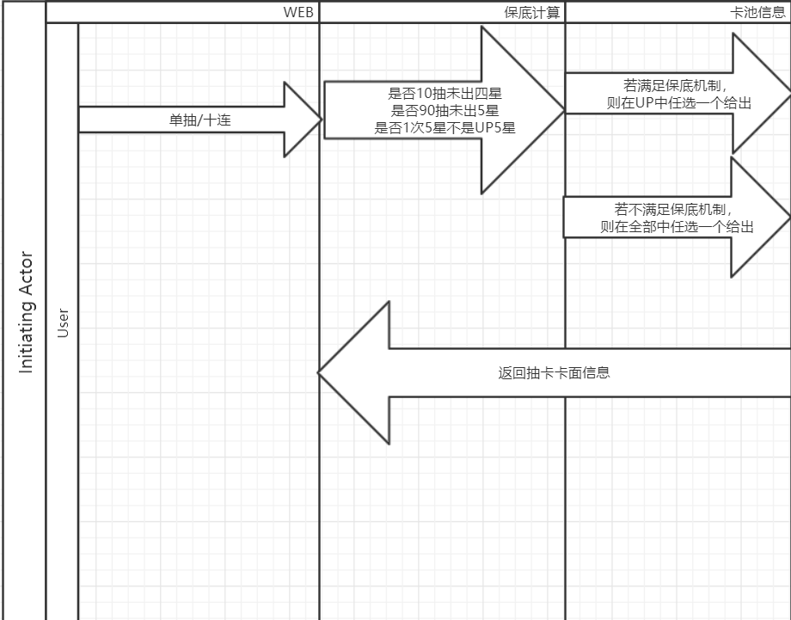

三、姜睿宇

(1) use case diagram

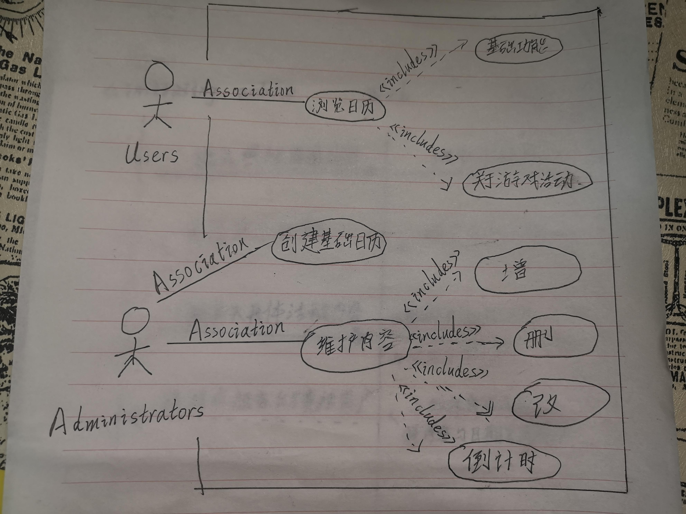

(2) use case schema

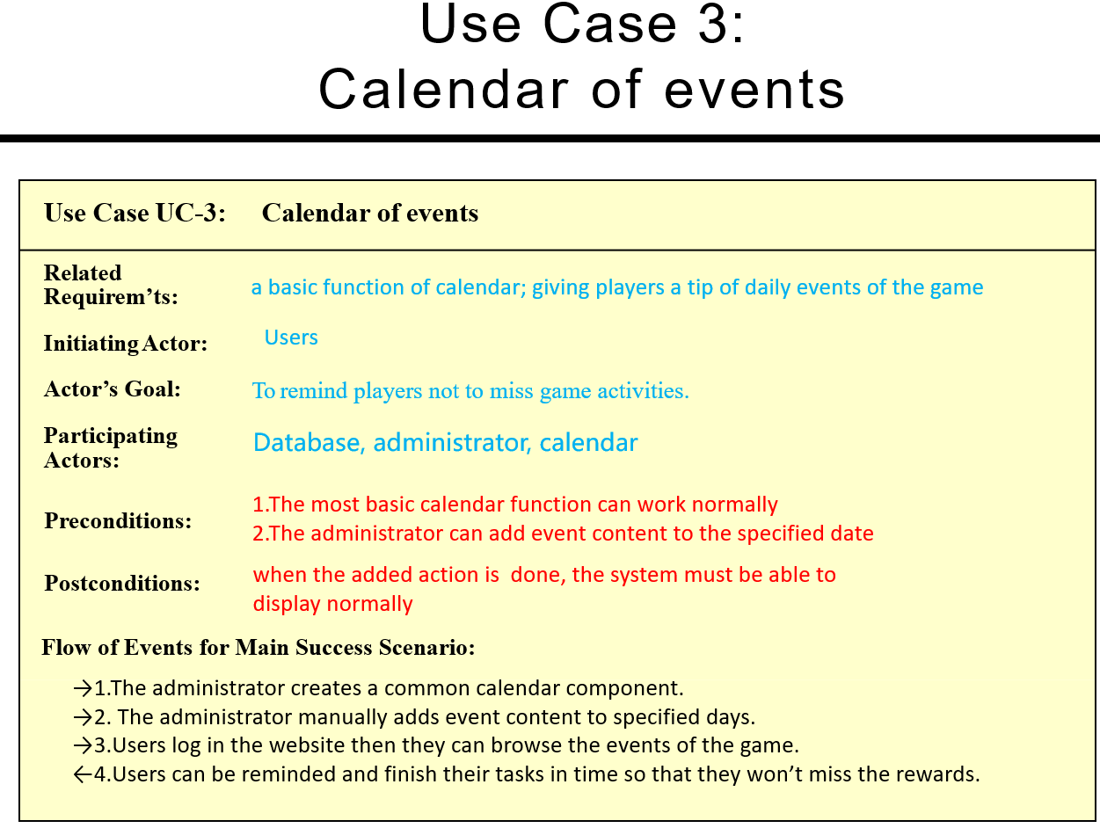

1. acceptance test

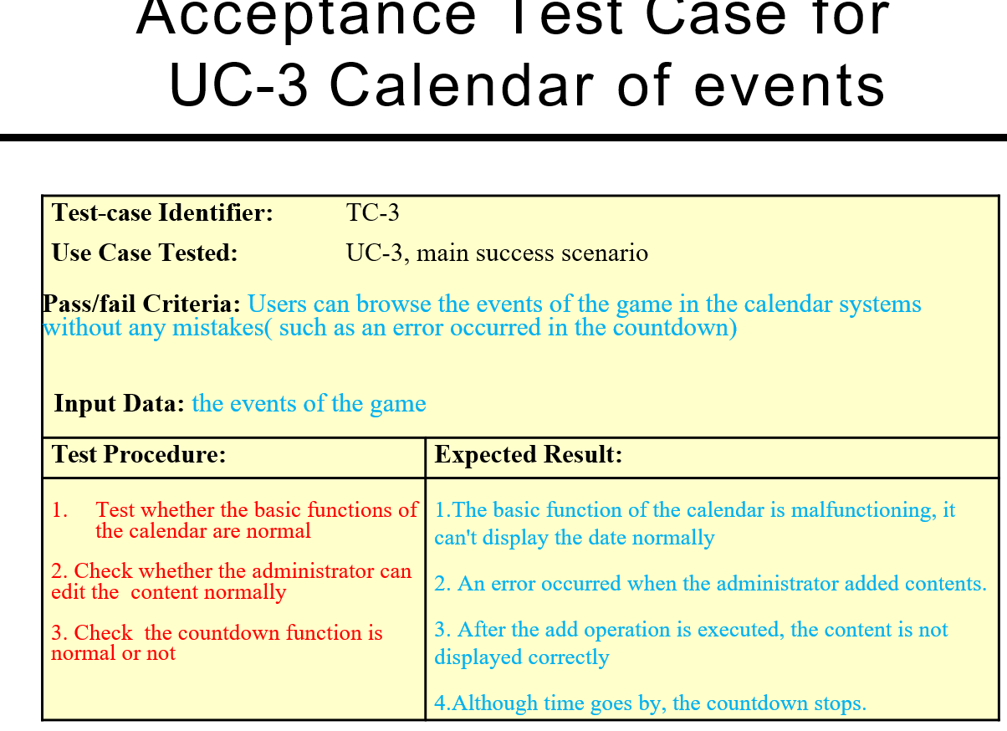

(4) system sequence diagram

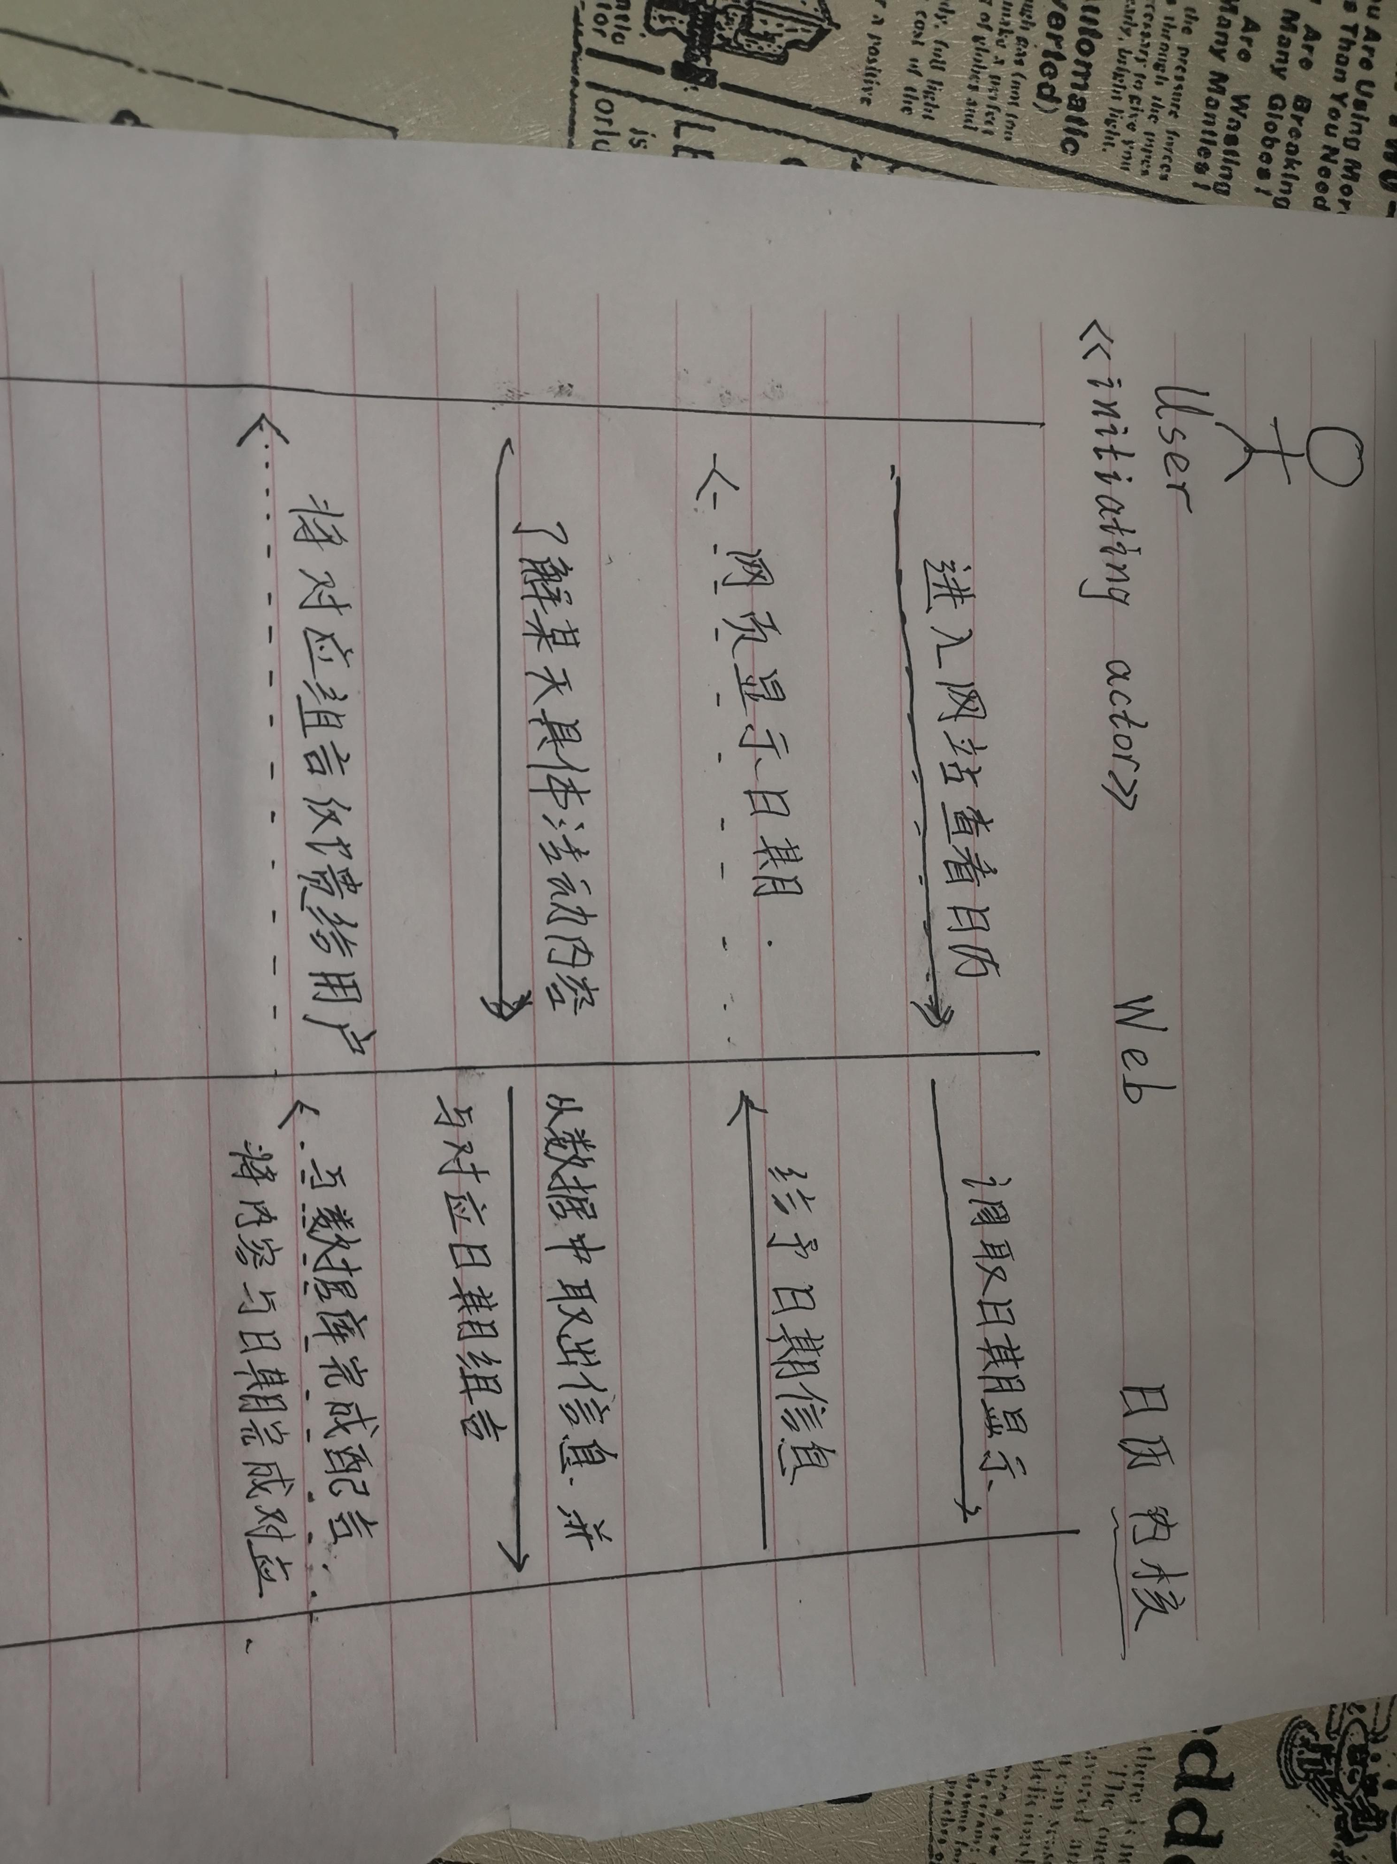

四、潘义

(1) use case diagram

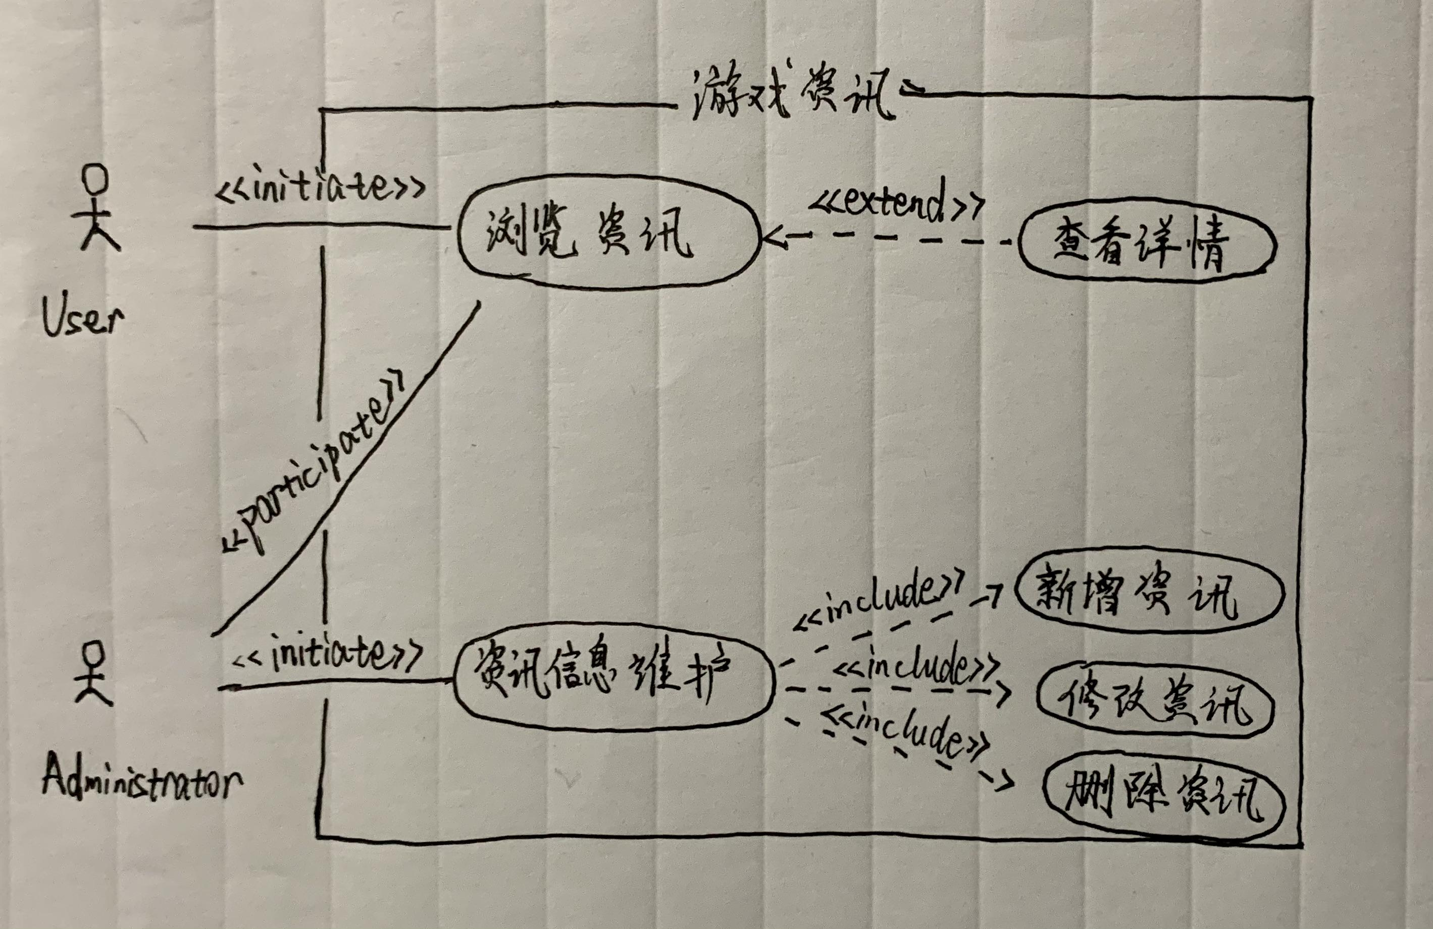

(2) use case schema

|  |  |
| --- | --- |
| Use Case UC-4 | 游戏资讯 |
| Related Requirements | REQ1:User查看游戏资讯  REQ2:Administrator维护游戏资讯信息 |
| Initiating Actor | User |
| Actor’s Goal | 查看游戏资讯 |
| Participating Actors | Administrator,Web,Database |
| Preconditions | User还未获取游戏资讯 |
| Postconditions | User已获取游戏资讯 |
| Flow of Events for Main Success Scenario | ->1.User 打开Web浏览资讯  ->2.User点击资讯进入详情页查看  <-3.Web为用户提供游戏资讯 |

(3) acceptance test

|  |  |
| --- | --- |
| Test-case Identifier | TC-4 |
| Use Case Tested | UC-4 |
| Pass/Fail Criteria | User能够顺利在Web里看到资讯并能够点击进入详情页面 |
| Input Data | Web网址 |
| Test Procedure | Expected Result |
| step1.在浏览器中输入网址并跳转  step2.在浏览器中输入网址并跳转 | 成功登陆进入网页并浏览到资讯条目  网页崩溃、网络连接中断、资讯出错无法显示等错误发生 |

(4) system sequence diagram

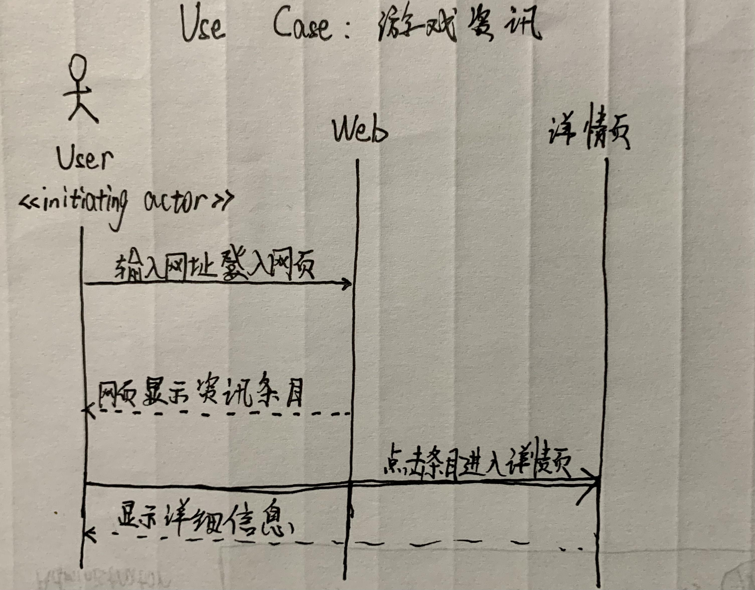

五、苏建锐

(1) use case diagram

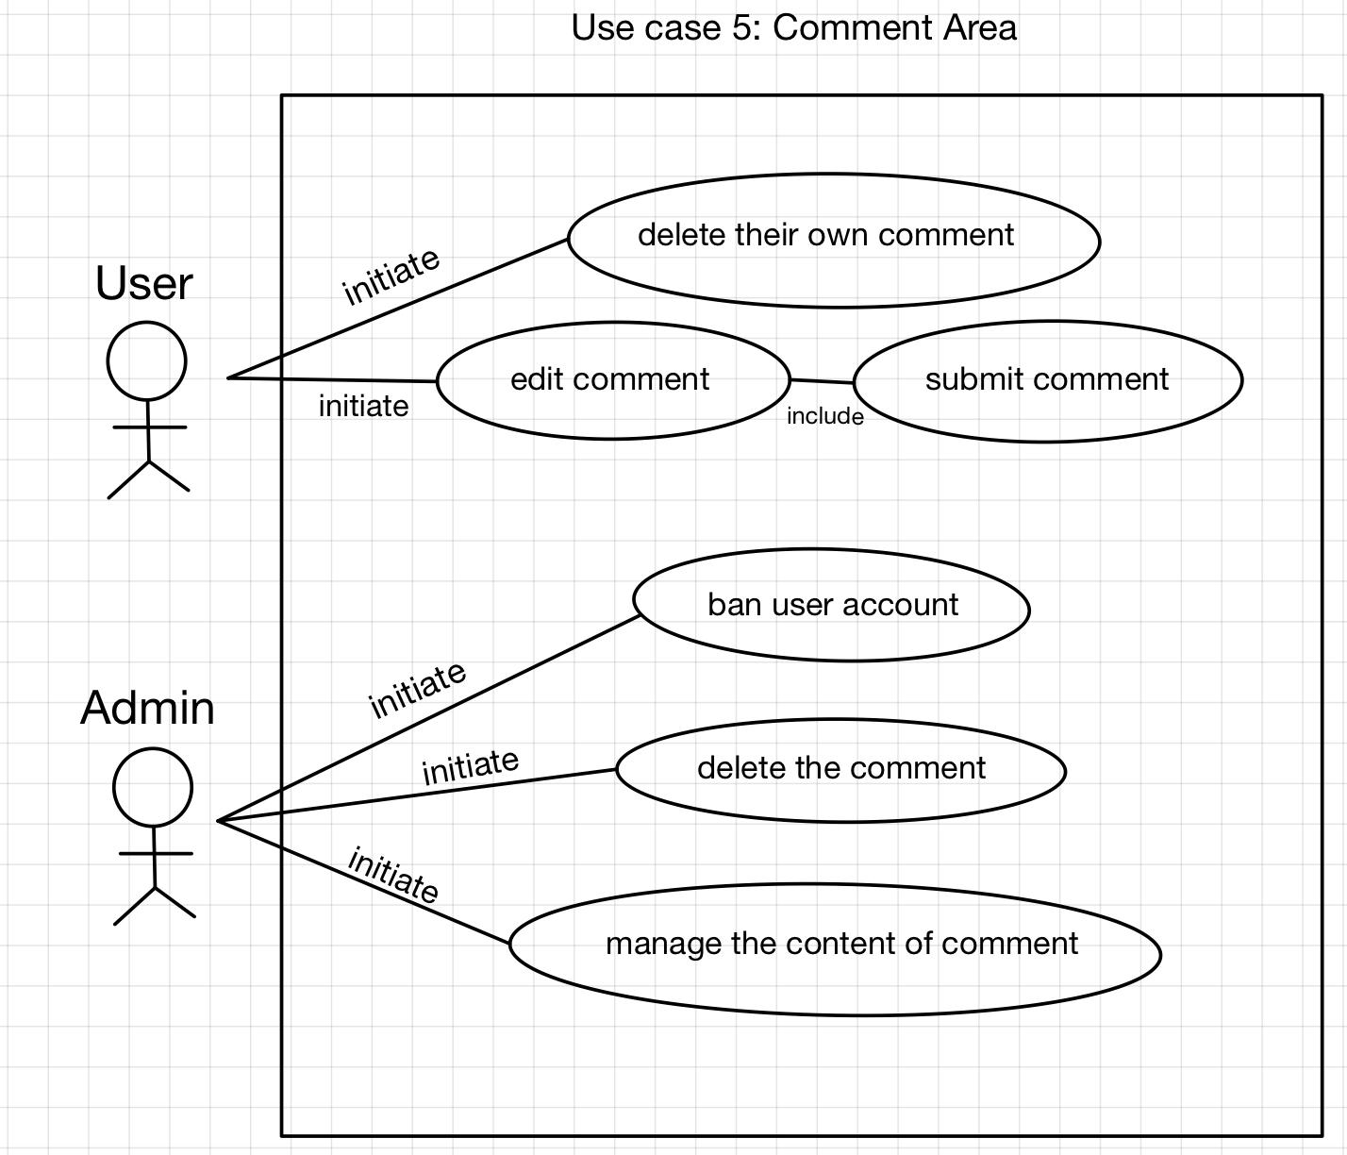

(2) use case schema

|  |  |
| --- | --- |
| **Use Case UC-5** | Comment Area |
| **Related Requirements** | Text box for entering comments,  Ability to submit comments,  Comments sorted by time/hotness, etc. |
| **Initiating Actor** | Users, Administrator |
| **Actor’s Goal** | **Users**: using the comment area to submit comments;  **Administrator**: Manage the content of comment, delete the comment, Disable the comment function of the account, ect. |
| **Participating Actors** | Users, Administrator,Database |
| **Preconditions** | Comment area & Submit button |
| **Postconditions** | Mutiple comments in list form |
| **Flow of Events for Main Success Scenario** | |
| → | 1. User enter a comment in the text box and click submit buttom |
| ← | 2. Comment request was sent to database, showing in the comment area |
| ← | 3. User can see their comment in the area. |

(3) acceptance test

|  |  |
| --- | --- |
| **Test-case Identifier** | TC-5 |
| **Use Case Tested** | UC-5 |
| **Pass/Fail Criteria** | Pass: User can sucessfully use a the comment funtion. & Admin can use their oermissions  Fail: On the comtrary. |
| **Input Data** | Some User accounts and a admin account, using comment area. |
| **Test Procedure** | **Expected Result** |
| **Step 1**: user account using the comment area to edit comments and submit.  **Step 2**: Using Admin account to ban the user account.  **Step 3**: Using admin account to delete the comment. | user account can see their comment in the area, and also the others.  the banned user account can not using the somment funtion.  Deleted comments will no longer appear in the comments area. |

(4) system sequence diagram

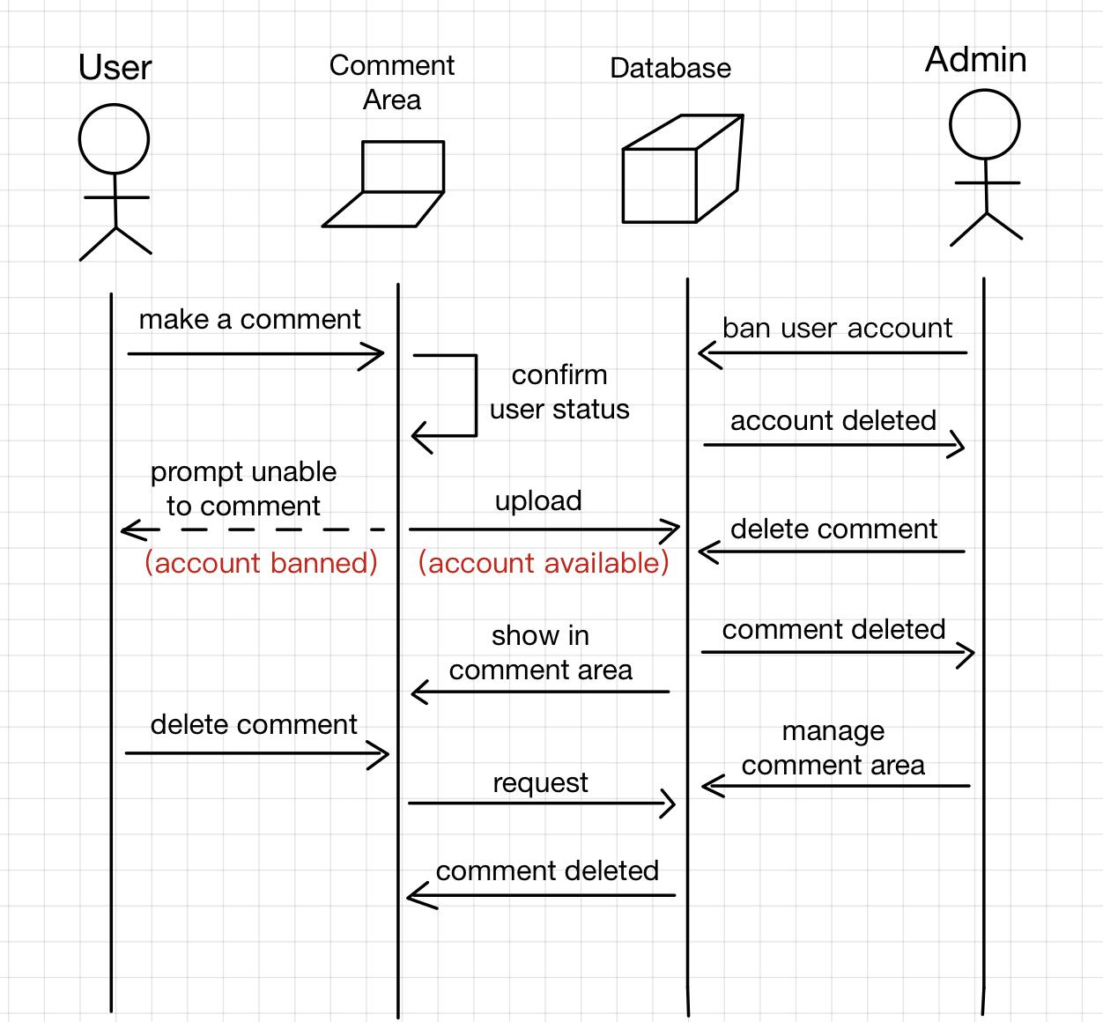

六、张培洋

(1) use case diagram

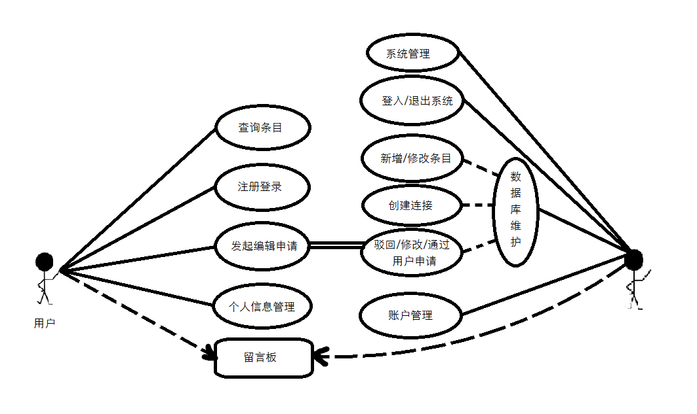

(2) use case schema

|  |  |
| --- | --- |
| Use Case UC-6 | 查询检索 |
| Related Requirements | 查询网页中的条目 |
| Initiating Actor | User, Database |
| Actor’s Goal | 检索网页中的特定条目并查看 |
| Participating Actors | User, Database |
| Preconditions | 搜索框供关键字检索 |
| Postconditions | 找到特定条目，可查看可编辑 |
| Flow of Events for Main Success Scenario | 如上图。 |

(3) acceptance test

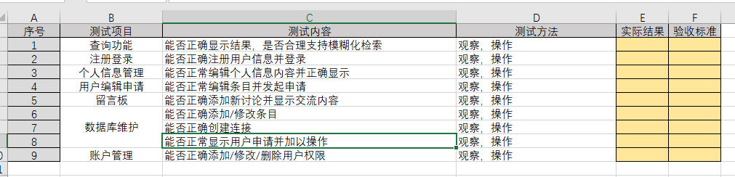

(4) system sequence diagram

